# CHAPTER 1: RESEARCH PROPOSAL

## 1.1.0 Abstract

The productivity and quality of plants are greatly influenced by plant diseases and pests. The detection of plant diseases and pests may be done via digital image processing. Deep learning has significantly outperformed conventional approaches in the field of digital image processing in recent years. Researchers are now very interested in how to employ deep learning technology to investigate plant diseases and pest detection. This paper defines the difficulty with detecting plant diseases and pests and makes a comparison to conventional techniques for doing so. This paper describes contemporary deep learning-based research on plant disease and pest detection from three perspectives: classification network, detection network, and segmentation network. The benefits and drawbacks of each approach are briefly discussed. Common datasets are presented, and the effectiveness of current research is contrasted. On the basis of this, this paper investigates potential issues in deep learning-based plant disease and pest identification in real-world settings. In addition, a number of recommendations are given as well as potential research directions and remedies for the problems. Finally, this paper analyses and predicts the future direction of deep learning-based plant disease and pest detection.

## Background

In the realm of machine vision, the identification of plant diseases and pests is a key study topic. It is a technique that takes plant photos and determines if they contain pests and diseases using machine vision equipment. Plant diseases and pest detection tools based on machine vision are currently being used in agriculture and have partially replaced the old-fashioned naked eye identification techniques. Traditional image processing algorithms or manual feature creation with classifiers are frequently employed for machine vision-based methods for detecting plant diseases and pests. This type of technique often uses the various characteristics of plant diseases and pests to construct the imaging scheme and choose the right light source and imaging angle, which is good to get photos with uniform lighting. Although correctly designed imaging schemes can significantly lessen the difficulty of designing traditional algorithms, they can raise the cost of the application. At the same time, it is sometimes impractical to anticipate that the traditional algorithms created to totally exclude the influence of scene changes on the recognition results will work in a natural context.

## Problem Statement

During the whole growth phase of plants, from seed development to seedling and seedling growth, plant diseases and pests are one type of natural catastrophe that affects the normal growth of plants and even results in plant mortality. Plant pests and diseases are frequently notions from human experience rather than simply mathematical definitions in machine vision jobs. The requirements for plant disease and pest identification are fairly generic in comparison to the specific classification, detection, and segmentation tasks in computer vision. In actuality, the requirements may be broken down into three categories: what, where, and how.

## Project Aim

The aim of this project is to minimise the negative effects of pests and diseases on plants and crops. This is possible through the use of an imaging system that is able to detect the presence of a pest of disease on a plant leaf, and also the severity of the plant damage.

## Objectives

* Implementation of Image processing to monitor a bed of crops/ plants.
* Detect diseases on plant leaves.
* Determine the severity of the damage done by the disease or pest on the plant.
* Classify the diseases and pests based on machine learning.
* Determine the better algorithms in this use case.

## Materials

* Datasets for model training
* Datasets for model testing
* Python Programming Language
* TensorFlow Library
* Nvidia Graphics Processing Unit
* Image processing Libraries
* Matplotlib
* Numpy
* notebook
* TensorFlow-addons
* TensorFlow-model-optimization
* Tensorflow

## Methodology

A deep learning-based image identification technology will be used in this plant disease detection system. When compared to traditional image recognition techniques, deep learning-based image recognition technology does not require the extraction of particular characteristics; instead, it can acquire global and contextual properties of pictures and has stronger resilience and greater recognition accuracy.

## Dataset

Dataset downloaded from Kaggle.com.   
<https://www.kaggle.com/datasets/kaustubhb999/tomatoleaf>.

## Proposed Time Allocation

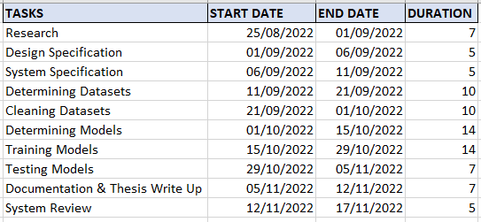

### 1.9.1 Gantt Chart

